**Find form and interfaces using output type**

1. Go to se16n
2. Table : TNAPR , Output type: *<output_type>*

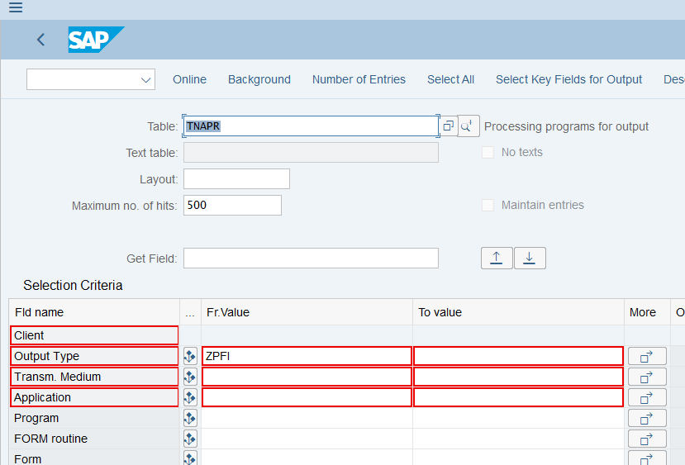

1. Press FN + F8

